Development of Control Strategies for Earthquake Reproduction

Afonso Henrique
Earthquake Engineering and Structural Dynamics Unit (NESDE/DE)
Laboratório Nacional de Engenharia Civil (LNEC)
Lisbon, Portugal
ahenrique@lnec.pt
Miguel Ayala Botto
IDMEC, Instituto Superior Técnico, Universidade de Lisboa, Portugal
ayalabotto@tecnico.ulisboa.pt
Fernando Oliveira
Modelling and Rock Mechanics Unit (NMMR/DBB)
Laboratório Nacional de Engenharia Civil (LNEC)
Lisbon, Portugal
fvoliveira@lnec.pt

Abstract— This paper presents two solutions for reproducing simulated earthquakes in an experimental laboratory shaking table through the design of model-based controllers. While recorded earthquake ground-motion time histories are generically simple to reproduce, the simulation study of their impact on experimental scale laboratory setups presents a major defying challenge. A procedure should be implemented to guarantee that the shaking table platform vibration response spectra during the earthquake reproduction matches the response spectra of the applied reference earthquake signal, while remaining unaffected by the vibrations resulting from the shaking table and the mounted scaled physical model. The proposed model-based control solutions consist of the design of a Filtered PID (PID-F) and a Linear Quadratic Integral (LQI) controller, both using the two‑stage closed-loop identification method for obtaining the system’s dynamic model. The performance validation of both controllers is demonstrated on a small-scale shaking table for eight different real benchmark earthquake ground-motion time histories and compared with the standard Online Iteration (OLI) method that is currently in use at the Laboratório Nacional de Engenharia Civil (LNEC). Both PID-F and LQI controllers are shown to outperform the OLI method. However, the LQI controller synthesized through the minimization of the squared error between the target and the output response spectra of the earthquake reference signal is shown to achieve the best performance. These results validate the effectiveness of using LQI controllers in reproducing simulated earthquakes at a laboratory scale.
Keywords— Earthquake Engineering, Control Systems, Closed-loop Identification,

Introduction
Earthquakes are among the most catastrophic natural events, frequently causing severe loss of life, extensive property damage, and significant socio‑economic disruption. One of the most effective ways to reduce seismic risk is by decreasing the structural vulnerability of the built environment, which can be assessed through experimental techniques such as shaking‑table testing.
Shaking‑table tests consist of mounting a physical model on a stiff platform that is driven so as to reproduce the desired ground‑motion time history (reference signal). This experimental technique was introduced in the 1940s and became widespread during the 1960s. Early systems relied on mechanical profiled cams to generate the excitation, but servo‑hydraulic systems soon became the standard solution ([1],[2],[3]). At the Laboratório Nacional de Engenharia Civil (LNEC) a Goodmans model VG-108 electrodynamic shaker attached to a movable table was installed in the 60s to perform seismic tests [4]. A uniaxial shaking table (ST1D) was developed and installed, consisting of a 3 m × 2 m horizontal steel platform and a vertical platform body driven by a hydraulic actuator supplied by a dedicated oil‑hydraulic circuit ([5], [6]). During this period, adaptive control strategies were developed, implemented, and validated both on a small scale shaking table and on the ST1D, for tracking reference earthquake spectrum (frequency domain), iteratively ([7],[8]). Increasingly demanding requirements for reproducing seismic excitation along all three directions motivated the development of the triaxial shaking table (ST3D), which has been installed and operational at LNEC since the mid‑1990s [4]. The reproduction of earthquakes on a shaking table depends strongly on: i) the hardware (mechanical and electrical system), which usually has limitations and therefore can distort the reference signal and; ii) the control system, whose performance is highly sensitive to the adopted control strategy and tuning. The hydraulic and control system supplier, MTS Systems Corporation (MTS), provided several control strategies: i) Three-Variable Control (TVC), also known in control theory literature as state variable control [9], which combines the displacement, velocity and acceleration feedback [1]; ii) Adaptive Harmonic Cancellation (AHC), suitable for sinusoidal signals (fixed frequency or sweep); iii) Adaptive Inverse Control (AIC) [10], suitable for non-sinusoidal signals on linear systems; iv) Amplitude/Phase Control (APC), suitable for sinusoidal signals (fixed frequency and sweep) and predominantly linear systems, and often used in conjunction with AHC to reduce distortions in nonlinear systems; v) Online Iteration (OLI), suitable for nonlinear systems and non-sinusoidal waveforms. This last strategy is the most appropriate for earthquake engineering applications, as structures may exhibit nonlinear behaviour or sustain damage during testing. OLI is currently the control method implemented at LNEC’s ST3D.
Shaking‑table control strategies typically begin with the offline generation of a drive signal using the inverse model of the system and the desired reference motion. This drive signal is then applied to the system, which usually incorporates a linear controller, most commonly a Proportional‑Integral‑Derivative (PID) controller, using actuator feedback signals (displacement, velocity, or acceleration) ([1], [11]). This is the basis of the OLI control strategy. Indeed, PID controllers remain widely used in most test systems, including shaking‑table and hybrid testing platforms [12]. Alternative control approaches have been proposed in the literature, including: i) Acceleration Trajectory Tracking Control (ATTC) [13]; ii) displacement feedforward-feedback controller using an optimal controller [14]; iii) Model-based feedforward-feedback controller for acceleration tracking [15]; iii) minimal control synthesis (MCS) strategy, which is feedback-feedforward adaptive control strategy including the inverse model in line with the reference signal [16].
For the OLI strategy currently implemented at LNEC’s shaking table, several limitations can be identified: i) the PID controller parameters are fixed and cannot be adapted to the device under test or to the characteristics of the reference signal; ii) the approach requires the offline computation of the drive signal to be fed into the system; iii) the procedure is iterative, often requiring multiple drive‑signal updates to achieve the target response, which increases testing time and may induce additional damage to the specimen. In this paper an alternative control methodology for shaking‑table testing is presented. The system is identified in closed-loop using the two‑stage method [17], then an optimized controller is synthesized for the identified model and the target earthquake signal. Two linear controllers were considered on this study: i) a PID-F controller, i.e. a PID with a filter on the derivative term, tunned to maximize the bandwidth while maintaining a unitary frequency response function (FRF); ii) a LQI controller, i.e. an optimal controller augmented with an integral of the tracking error, whose weighting terms are tunned with the Nelder-Mead simplex optimization algorithm [18], such that the optimal state feedback law minimizes the mean squared error between the target and output response spectra. The best controller obtained from this process is then selected for implementation. Eight earthquake records [19] were considered to evaluate the performance of the proposed methodology on a small‑scale shaking table equipped with both a PID-F and an optimal LQI controller. Numerical simulations based on the identified physical model demonstrate that these two strategies outperform the OLI control approach currently used at LNEC, with the LQI controller exhibiting the best performance. These results partially validate effectiveness of the proposed methodology and confirm the previous results obtained with the numerical model of the ST1D shaking table [17]. The physical implementation of the controller will be carried out in the near future to fully confirm and validate the approach on the experimental system.
This paper starts in Section I with a brief introduction to the shaking table control problem, summarizes previous work, describes the proposed methodology outlining the control strategies to improve the system performance. The control strategy currently in use and the experimental set‑up available at LNEC are described in Section II, followed by the detailed presentation of the methodology in Section III and the corresponding results in Section IV. The paper concludes with the main findings and outlook for future developments.

LNEC’s Shaking Table Test process & Control system
The current control strategy implemented in the LNEC’s shaking table tests is based on the OLI algorithm. It involves the iterative synthesis of a drive signal with progressively increasing severity, aiming to ensure that the platform accurately reproduces the response spectra of the reference signal, i.e., the target earthquake (Fig. 1).
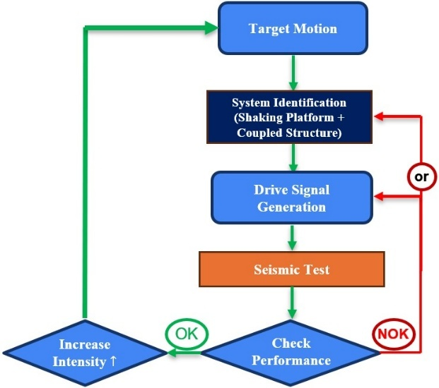
- LNEC’s seismic test process
The process depicted in Fig. 1 consists in testing the structure to a series of test steps starting at a low severity earthquake (scaled earthquake) and then repeated with the same earthquake at higher severity (higher amplitude), and so on until a defined amplitude is reached, which usually corresponds to the original amplitude of the earthquake – reference severity. At each test step the structural damage is accessed and, before starting a test step, an identification of the system's transfer function is carried out using a limited-band pink noise signal (slope of -10dB/decade). This transfer function is then used in the command signal generation algorithm to generate the drive signal for each test step. Throughout this process, the amplitude of the reference signal increases progressively, and it is expected that the structure will enter a non-linear regime, either due to the behaviour of some of its components or the damage accumulated during the various tests. At each test step, the system's performance is evaluated by comparing the response spectrum of the reference signal with that of the signal measured on the platform (Fig. 2). The response spectrum is a fundamental concept in earthquake engineering and structural dynamics, as it represents the maximum response (such as displacement, velocity, or acceleration) for each natural frequency of a single degree of freedom mass-spring-damper system subjected to the ground motion. It represents how structures respond to a specific earthquake ground-motion record and is used to characterize earthquake severity.
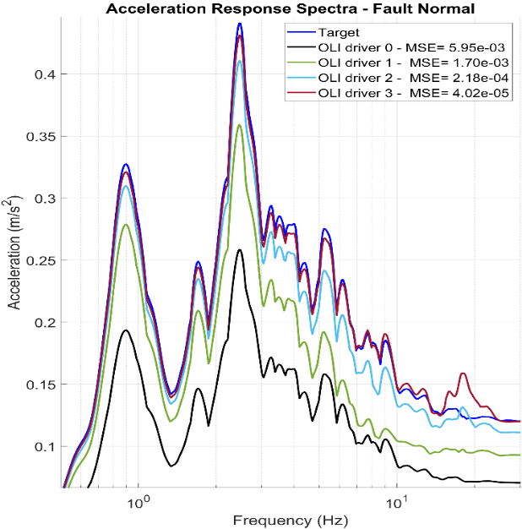
- Acceleration response spectrum evolution. Four iteratively generated drive signals (for scaled L’Aquila seismic signal) were needed for acceptable performance.
Consequently, different earthquake time histories can correspond to the same response spectrum, meaning they have the same severity. However, it is not always possible to achieve satisfactory performance with the command signal synthesized initially, and it may be necessary to generate more than one command signal and carry out additional test steps. This procedure, although necessary to fit the spectrum, it induces additional damage to the structure. Additionally, physical limitations inherent to the equipment, namely with regard to the finite field of displacement, velocity and acceleration, must be duly considered during the tests.
To overcome these limitations a control methodology for shaking-table using an optimized linear controller, the identified model of the system and earthquake recorded is being proposed. The performance of the system will be evaluated with two candidate controllers: a PID-F and an optimal LQI controller.
An experimental facility comprising a small-scale shaking table with dedicated hardware and software is used to validate the methodology. The measurement and control chain is depicted on Fig. 3 and, consists of: i) Shaking Table, including a small-scale shaking table installed on a fixed base, along which it rolls over, driven by a Goodmans model 390A electrodynamic shaker, and a Linear Variable Differential Transformer (LVDT) measures the relative displacement of the platform; ii) Conditioning and Control unit, with a hardware rack comprising all required signal conditioning and control components, including sensor signal conditioners and a National Instruments PXI Real-Time Controller integrated with a CompactRIO system featuring a Virtex-5 FPGA, enabling autonomous real-time execution of control and acquisition tasks; iii) and, Data Acquisition System comprising a host PC, where the experimental setup is configured using the NI LabVIEW environment, including the implementation and supervision of the control strategy, the data acquisition set-up, as well as the measurement and visualization of the experimental results.
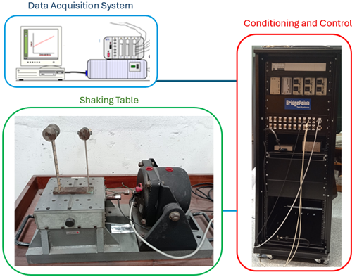
- Experimental facility
One key advantage of this system framework is the modularity, since both data acquisition system and the condition and control rack can be deployed with other experimental set-ups. In particular, the system can be reused with the ST1D shaking table, where the proposed control strategies will be subsequently validated.
The system under study is a closed-loop control system, schematically illustrated in Fig. 4, comprising: i) a controller, for which both a PID-F controller and an optimal LQI controller are considered in this study; and ii) a controlled system consisting of the shaking-table hardware, including its mechanical and electrical components, together with the top-mounted physical model. The control objective is that the output signal y, corresponding to the shaking-table motion, tracks the reference signal r, corresponding to the earthquake signal, as closely as possible.

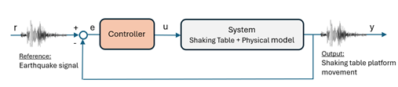
- Shaking table control loop
The control strategy currently implemented at LNEC is the OLI control approach. For the majority of applications, the PID controller parameters are tuned in advance for a specific test configuration and subsequently kept fixed throughout most experimental campaigns.

Methodology

Foreword
This section details the methods with which the identification of the plant, tuning of controllers, and evaluation of controller performance is carried out. Firstly, the two-stage closed-loop identification method [17] is applied to address the problem of consistent identification in closed-loop system. The following section describes the open-loop driver signal design process currently used at LNEC (which will serve as a baseline for controller performance evaluation), and two proposed developments for the shaking table control system. These developments consist on a systematic approach to designing optimized controllers of two different structures: a PID-F controller (for simplicity of implementation on the existing control system software and hardware), and an optimal controller (for greater performance).

System identification
The dynamic model identification of the plant is needed for tunning the controllers. To this end an identification experiment is carried out using a limited-band pink noise driver signal, with amplitude of approximately ±4 mm, with the controller set with proportional gain K_{p}=10, and data acquisition at 200 Hz. A sampling period of 5 ms is used throughout. The imperative of running experiments under closed-loop control poses additional challenges for identifying the plant (shaking table with physical model). To address the particularities of a closed-loop identification, the two-stage method [17] illustrated in Figure 5 is applied. Firstly, the sensitivity function with controller, S₀C, is identified by fitting a linear FIR model with 100 parameters (the order of the model just needs to be high enough to reproduce the noise-free control action, and high variance is not of concern). Then a Hammerstein-Wiener model is defined, using the previously identified FIR model as the linear block, and with the output nonlinearity equal to that of the physical system (saturation of the control action at known values), resulting in a more refined model for the sensitivity function. This function is then used to compute the noise-free control action u_{r}, from which (by being uncorrelated with the output y) the plant G₀ can now be estimated without bias introduced by the controller in the feedback loop.
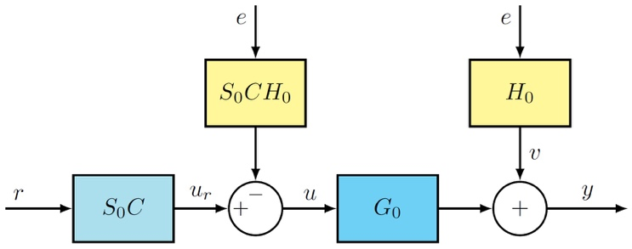
- Block diagram illustrating the two-stage method, with S₀ being a Hammerstein-Wiener model to better represent the real system dynamics with control action saturation (C – controller; S₀ – sensibility function; G₀ – model plant; H₀ – noise model; e – white noise; u_{r} – noise free control action).

Control Strategies
LNEC’s driver signal iterative adaptation process: This control technique is known as Online Iteration (OLI) [MTS Systems], as it iteratively modifies the command input on an individual sample-by-sample basis until the system response is close to the target.
This method compensates the next drive signal with a drive correction signal which is computed from filtering the previous iteration error with the inverse model of the closed-loop frequency response function. The closed-loop frequency response function (FRF) is estimated via a nonparametric identification method by spectral analysis. To this end, the user interface of the driver iteration program allows many different settings for the identification. For the simulations of the OLI method, the identification used the same experimentally acquired data with the band-limited pink noise, and the FRF identification settings use Hanning window with the number of windows set to 8192 with 97% overlap, and the FRF mode is set to H3. During the driver adaptation process, settings such as correction factor and maximum frequency compensation are adjusted as needed, while the coherence threshold is left at 90%.
The closed-loop transfer function used in the simulations of the OLI method was estimated by direct identification (from signals “r” and “y”, resorting to Fig. 4), and its frequency response is shown in Fig. 6.
PID-F control strategy: Taking into consideration the test procedure at LNEC (Fig. 1), where the identification is carried out each time the target signal is scaled up, one possible straightforward improvement would be to update the controller tune accordingly using this information. Another simple enhancement would be to add a filtered derivative term to the PI controller (making it a PID-F), since this should be of simple implementation in the existing version of the control software, as it is merely an extension of the existing controller structure, and allows more tuneability. This is precisely what was done: optimize the PID-F gains to the identified plant dynamics.
The simulations with the PID-F controller use the plant model resulting from the two-stage identification and the controller itself to close the loop.
LQI control strategy: The controllable canonical form state space representation of the plant transfer function obtained via the closed-loop two stage method identification is used in the minimization of the LQI cost function:
$J\left(u\left(t\right)\right)=\sum_{0}^{∞}{{x\left(t\right)}^{⊺}Q}x(t)+{u\left(t\right)}^{⊺}Ru(t) dt$ (1)
where Q and R have appropriate dimensions, with R=1 and Q being a diagonal matrix where each parameter was found via Nelder-Mead simplex algorithm [18] in order to minimize the acceleration response spectrum MSE for the seismic signal on test, computed for 100 logarithmically spaced points between 0.1Hz and 30Hz. The optimal state feedback control law is given by u(t) = K [x(t) x_{i}(t)]^{T}, with x_{i}(t) being the integral of the tracking error.
The simulations with the LQI controller use the plant model resulting from the two-stage identification, and the controller itself to close the loop.

Performance evaluation
A set of recorded earthquake ground-motion time histories covering a wide range of seismic characteristics are considered in this study, namely [19]: i) 1940 Imperial Valley earthquake, El Centro Fault Normal (FN) and Fault Parallel (FP) records; ii) 1992 Erzikan earthquake, Erzikan North-South (NS) and East-West (EW) record; iii) 1995 Kobe earthquake, Kobe NS and EW records; iv) 2009 L’Aquila earthquake; v) 1994 Northridge earthquake, Newhall FN and FP records; vi) 1994 Northridge earthquake, Rinaldi FN and FP records; vii) 1994 Northridge earthquake, Sylmar FN and FP records; viii) 1976 Friuli earthquake, Tolmezzo record. To ensure that the imposed inputs remained within the displacement capacity of the shaking table, appropriate scale factors were computed by taking the quotient of maximum desired displacement of 4 mm with the maximum displacement of any direction of the seismic signal (rounded to 3 decimal places) and then applied to the ground-motion signals.
The performance of each control method is evaluated through the acceleration and displacement response spectrum mean squared error (MSE) for every input action described in the previous section. The acceleration response spectrum is computed from 0.1 Hz to 30 Hz for 500 logarithmically spaced points, and the displacement response spectrum is computed for the same frequencies, however, for only the first 344 points, equating to a range from 0.1 Hz to 5.04 Hz.

Results

System identification & controller tunning
The closed-loop frequency response obtained with each control method is shown on the Bode plot of Fig. 6.
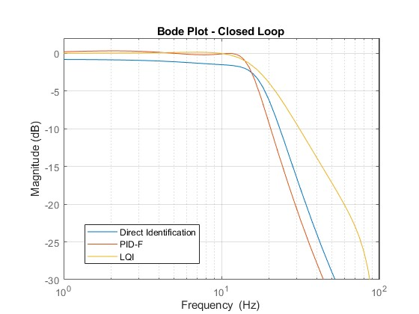
- Shaking table control loop frequency response with controllers optimized for the Tolmezzo earthquake.
The frequency responses clearly highlights the benefits of optimizing the controllers (PID-F and LQI) since a larger bandwidth is obtained while maintaining a unitary gain at lower frequencies. This directly translates to improvements in the response spectrum, which will meet the target on the first run, instead of not requiring several iterations.

Summary of results
The results obtained with the proposed methodology show how the tunning/optimization can improve significantly the performance of the system. It can be observed in Fig. 7 and Fig. 8 for acceleration and displacement response spectra of Tolmezzo earthquake, respectively, that the PID-F controller closely matches the target response, the LQI achieves an even closer match, whereas the OLI method (LNEC’s approach) remains further from the target even after the third drive iteration. The MSE values quantify the differences observed among the curves.
The results obtained for the remaining earthquakes exhibit the same trend, as shown in Fig. 9 and Fig. 10. This analysis confirms the benefits of using the proposed methodology, consistently identifying the LQI controller as the one that achieves the best closed-loop performance results.

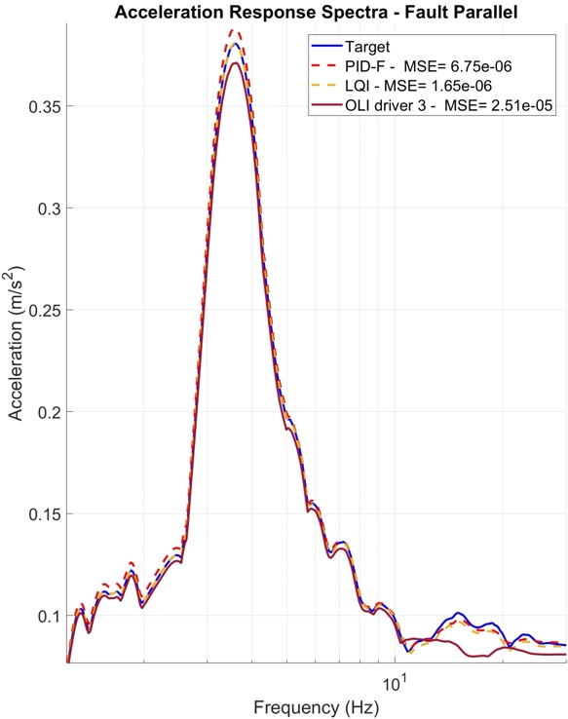
- Comparison of the acceleration response spectrum for a scaled down Newhall (FP) seismic signal
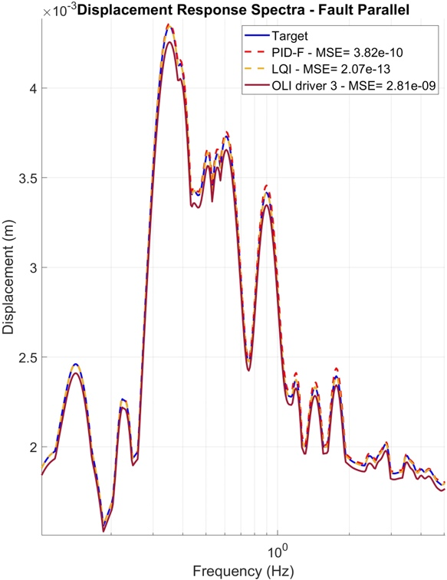
- Comparison of the displacement response spectrum for a scaled down Newhall (FP) seismic signal
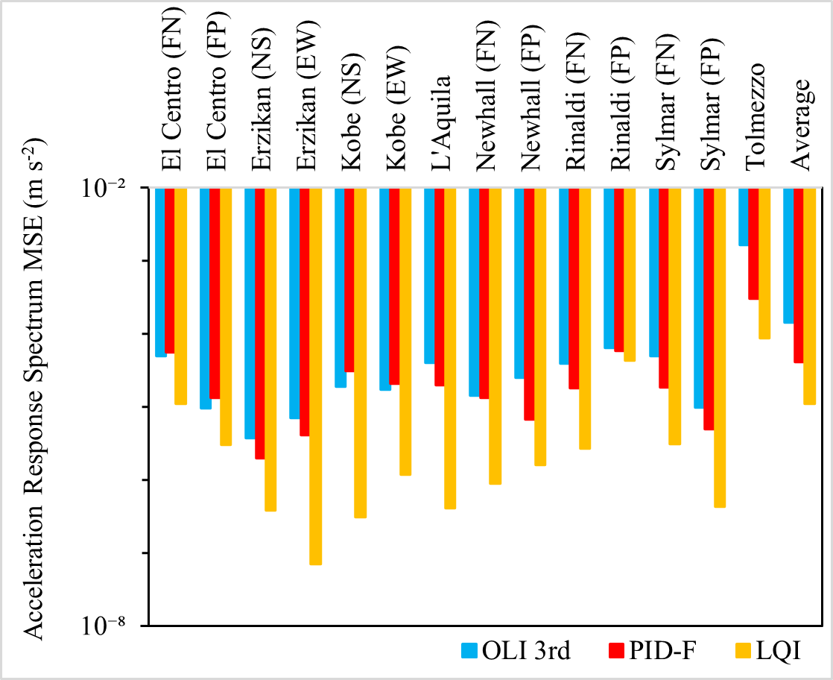
- Comparing OLI, PID-F and LQI acceleration spectrum performance.
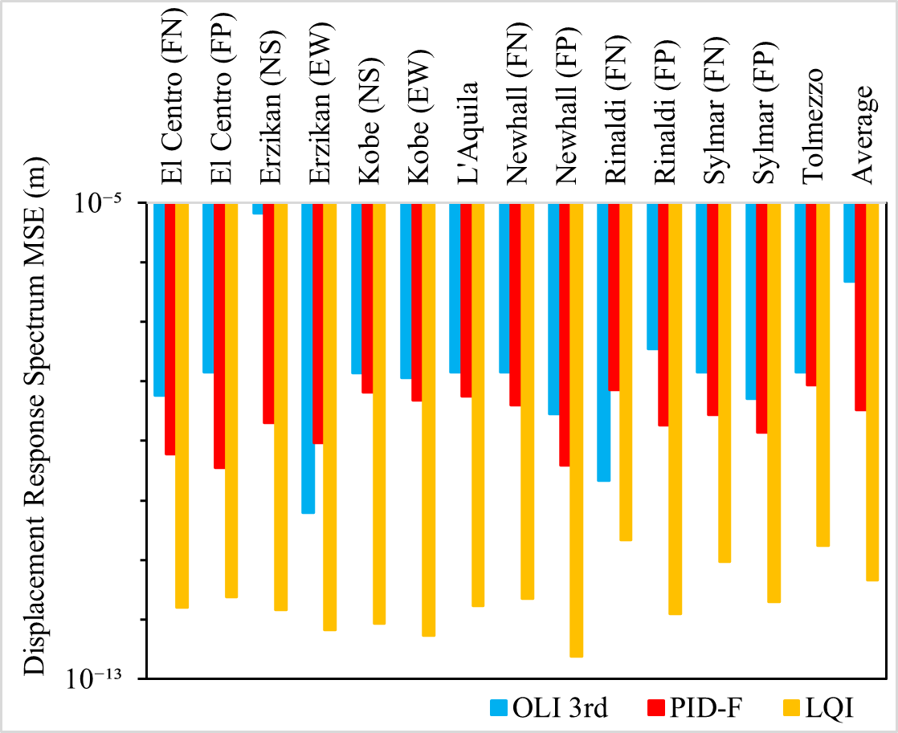
- Comparing OLI, PID-F and LQI displacement spectrum performance.

Conclusions & Outlook

This paper presents an improved solution to the current OLI method used in LNEC to experimentally reproduce simulated earthquakes in laboratory shaking table setups. Based on model-based controllers and using the two-stage closed-loop identification method to identify the plant and optimize the controllers, the PID-F and the LQI controllers were shown to reproduce the target response spectra across the whole frequency spectrum of the earthquake signal more accurately on the first run when compared with the standard OLI method fourth run. The tuned controllers (PID-F and LQI) also require less user intervention, and moreover, offer a systematic approach to the control problem with LQI controller providing the best results by significant margin for all earthquake ground-motions simulations.
Given the nature of seismic table experimental testing, the test specimens are often driven to plastic deformation, some form of failure, or have significant nonlinear behavior which is not detectable in the small intensity identification experiments. This results in non-negligible shifts in dynamic properties and excitation of unknown modes that may occur during the test, and the proposed method of optimizing controllers for the plant dynamics cannot account for this, so further investment should be directed to the implementation of adaptive online identification methods that can inform nonlinear control strategies in order to address both the evolving and nonlinear test specimen dynamics.
The final step of the proposed methodology consists in implementing the optimized controllers on the physical system (small-scale shaking table). Completing this step will close the loop of the methodology and will enable the verification and confirmation of the results and the achieved performance. Subsequently, the methodology is intended to be implemented on LNEC’s uniaxial shaking table, where the same analysis will be conducted to assess its effectiveness on larger‑scale systems. This future stage aims to evaluate the scalability, robustness, and practical applicability of the proposed control strategy under more demanding testing conditions. After demonstrating their superior performance, the proposed methodology will be applied on future shaking table tests.

Acknowledgment

The authors acknowledge LNEC for its financial support through the research fellowship under the LNEC Research Programme Modelação do Comportamento Estrutural- Mestr, and Fundação para a Ciência e a Tecnologia (FCT) for its financial support via LAETA (project https://doi.org/10.54499/UID/50022/2025).

References

- S. J. Chapman, M. S. Williams, A. Blakeborough, “Laboratory testing of structures under dynamic loads: an introductory review”. Philos Trans A Math Phys Eng Sci; 359 (1786): 1651–1669, 15 September 2001. https://doi.org/10.1098/rsta.2001.0860
- E. C. Carvalho, “Seismic Testing of Structures”, 11th European Conference on Earthquake Engineering, Balkema, Rotterdam, 1998.
- P. X. Candeias, A. A. Correia, G. G. Tekeste, “Shake Table Testing Techniques: Current Challenges and New Trends,” In: Chastre, C., Neves, J., Ribeiro, D., Neves, M.G., Faria, P. (eds) Advances on Testing and Experimentation in Civil Engineering. Springer Tracts in Civil Engineering. Springer, 2023. https://doi.org/10.1007/978-3-031-23888-8_8
- T. Emílio, R. T. Duarte, F. Carvalhal, C. O. Costa, C. T. Vaz, M. R. Corrêa, The new LNEC shaking table for earthquake resistance testing”, Memória 757, LNEC, Lisboa, 1989.
- R. Bairrão, Duque, Simulador Sísmico Uniaxial - Descrição e operação, Relatório LNEC, 94/1998 - C3ES/SES, LNEC, Lisboa, 1998.
- P. Castro, Mesa Vibratória Vertical (Projeto), Relatório LNEC, Obra 76/53/1077, LNEC, Lisboa, June 1978.
- F. Carvalhal, Simulation of Seismic Disturbances Using Adaptive Control, MSc Thesis, Victoria University of Manchester, Institute of Science and Technology, October 1974.
- F. Carvalhal, Controlo Adaptativo na Simulação de Solicitações Sísmicas, Tese para Especialista LNEC, STG/DPA, Proc. 76/13/5588, Lisboa, January 1979.
- K. Ogata, Modern Control Engineering. 5th Edition, Pearson, Upper Saddle River, 2010.
- B. Widrow, E. Walach, Adaptive Inverse Control: A Signal Processing Approach, Institute of Electrical and Electronic Engineers, July 2007. DOI:10.1002/9780470231616
- A. Henrique, M. Ayala Botto, F. Oliveira, “Development of control strategies for earthquake reproduction on uniaxial shaking table,” 13º Congresso Nacional de Mecânica Experimental – CNME2026, Universidade do Porto, Porto, 2026.
- G. G. Tekeste, Real-Time Hybrid Simulation including a Shaking Table – Development and Application to Soil-Structure Interaction. PhD Thesis, University of Aveiro, 2021.
- N. Nakata, “Acceleration trajectory tracking control for earthquake simulators,” Engineering Structures, 32(8), 2229–2236, 2010. https://doi.org/10.1016/j.engstruct.2010.03.025
- B. M. Phillips, B. F. Spencer, “Model-based feedforward-feedback actuator control for real-time hybrid simulation,” Journal of Structural Engineering, 139(7), 1205–1214, 2012. https://doi.org/10.1061/(ASCE)ST.1943-541X.0000606
- B. M. Phillips, N. E. Wierschem, B. F. Spencer Jr, “Model-based multi-metric control of uniaxial shake tables,” Earthquake Engineering & Structural Dynamics, 43(5), 681–699, 2014. https://doi.org/10.1002/eqe.2366
- D. P. Stoten, E. G. Gómez, “Adaptive control of shaking tables using the minimal control synthesis algorithm,” Philosophical Trans. Of The Royal Society 359(1786):1697-1723, Setember 2001. DOI:10.1098/rsta.2001.0862
- P. M. J. Van Den Hof, R. J. P. Schrama, “An indirect method for transfer function estimation from closed loop data,” Automatica, Volume 29, Issue 6, Pages 1523-1527, 1993. DOI: 10.1016/0005-1098(93)90015-L.
- J. C. A. Lagarias, Reeds, M. H. Wright, P. E. Wright. “Convergence Properties of the Nelder-Mead Simplex Method in Low Dimensions.” SIAM Journal of Optimization. Vol. 9, Number 1, 1998, pp. 112–147. DOI:10.1137/S1052623496303470
- S. Narasimhan, S. Nagarajaiah, E. A. Johnson, H. P. Gavin, “Smart base-isolated benchmark building. Part I: problem definition,” Structural Control and Health Monitoring 13:573–588, 2006. DOI: 10.1002/stc.99

